МІНІСТЕРСТВО ОСВІТИ І НАУКИ УКРАЇНИ

СХІДНОУКРАЇНСЬКОГО НАЦІОНАЛЬНОГО УНІВЕРСИТЕТУ

імені ВОЛОДИМИРА ДАЛЯ

Звіт

з лабораторної роботи № 2

# з теми: «ЗНАКОМСТВО С пРОГРАММИРОВАНИЕМ НА JAVA. ПРОГРАМИРОВАНИЕ РАСЧЕТНОГО ANDROID-ПРИЛОЖЕНИЯ»

Виконав студент:

Група КН-18д

Скороход С.Г.

Дата 10.04.2020

**м. Северодонецьк**

2020

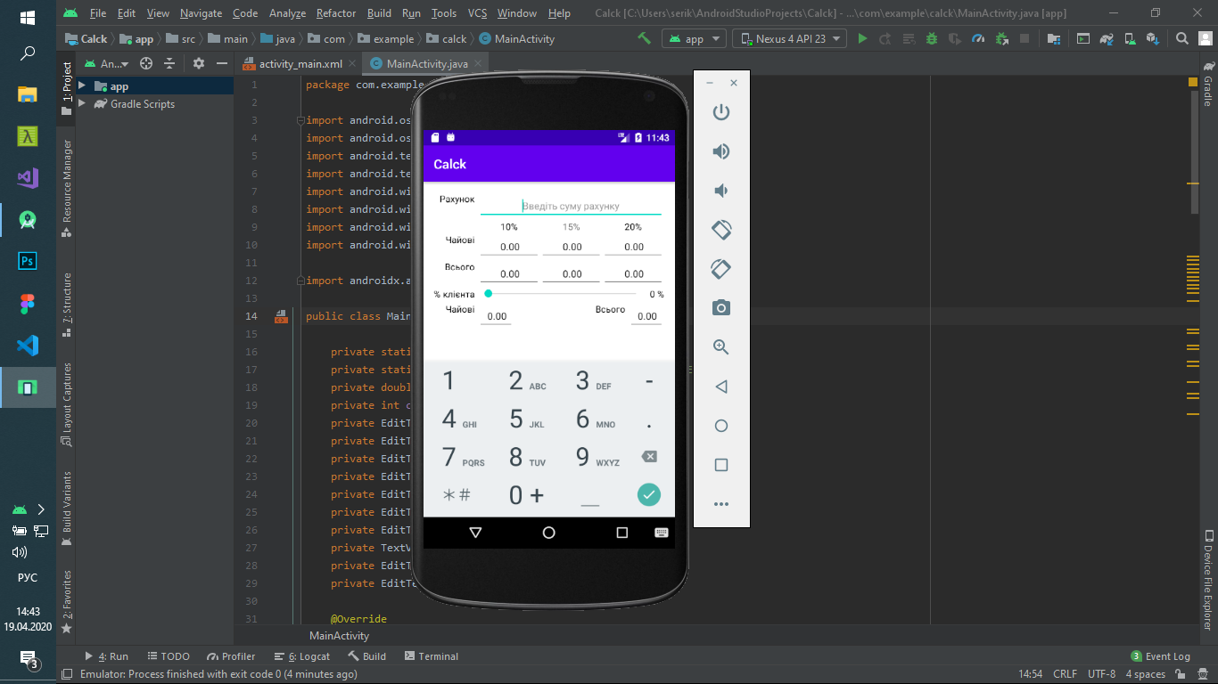

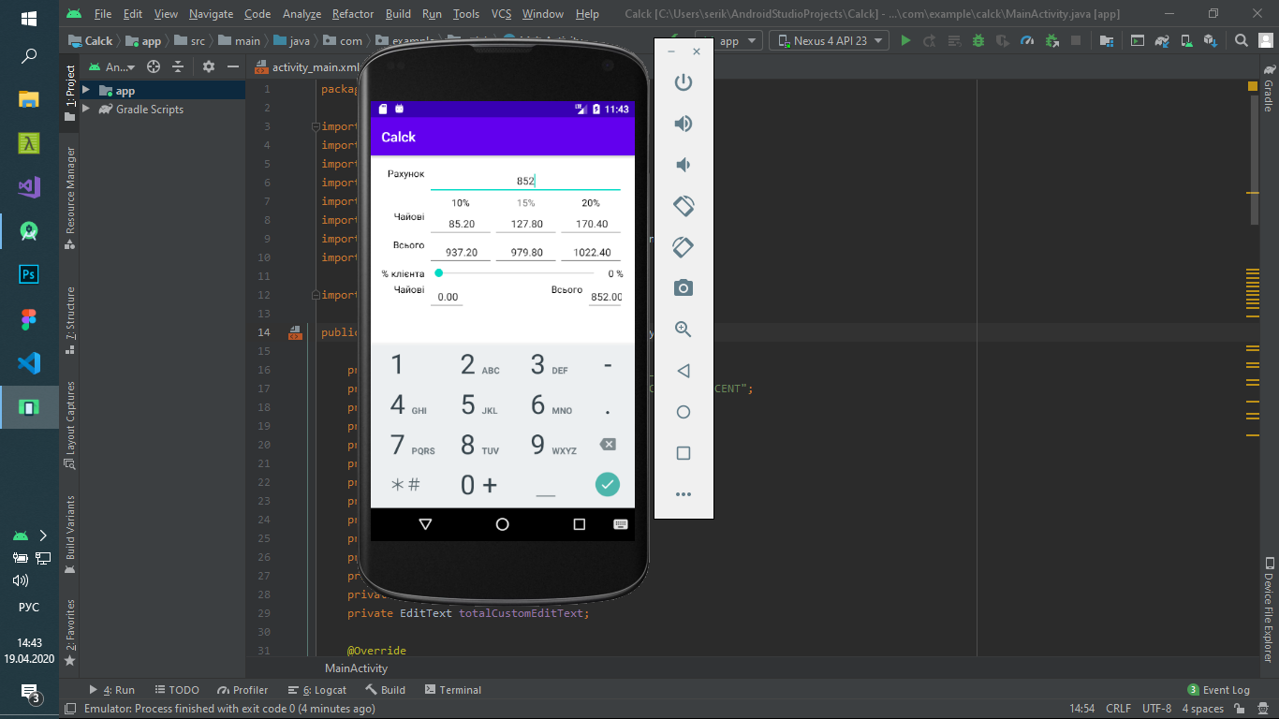

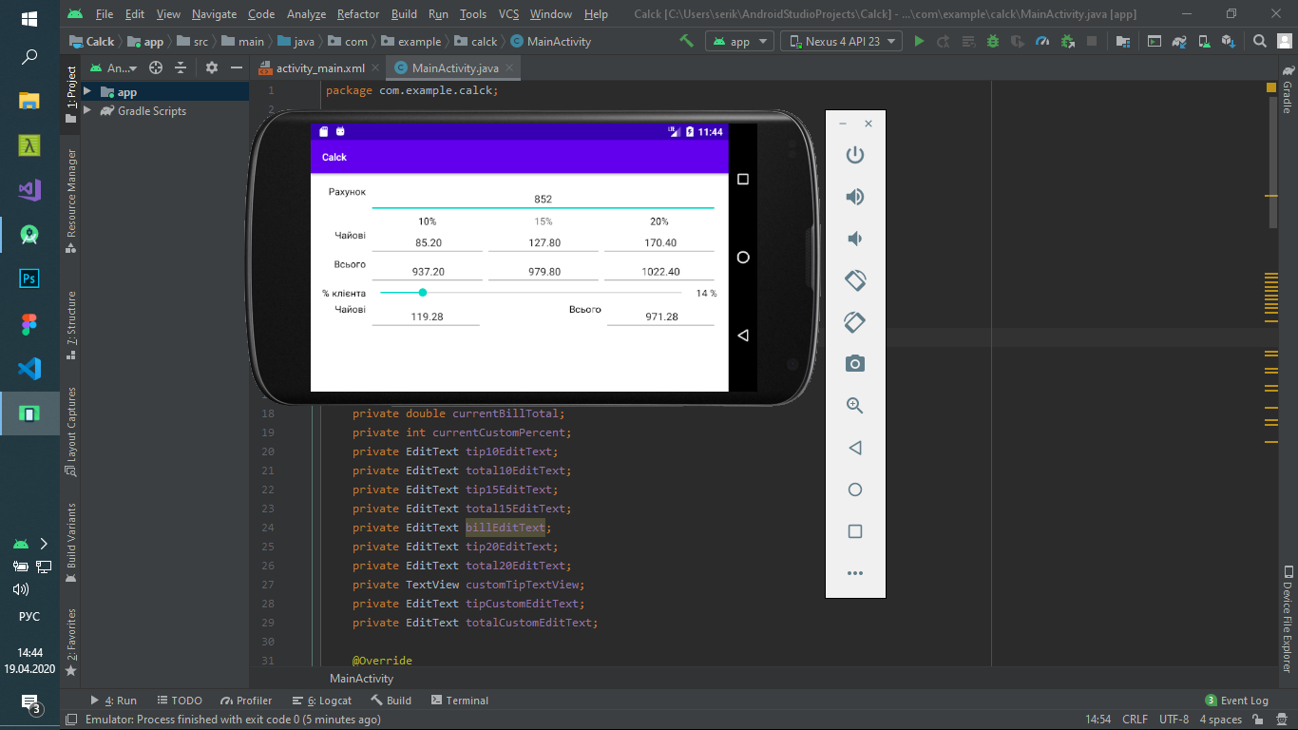

**Activity_main.xml**

<?xml version="1.0" encoding="utf-8"?>  
<androidx.constraintlayout.widget.ConstraintLayout xmlns:android="http://schemas.android.com/apk/res/android"  
 xmlns:app="http://schemas.android.com/apk/res-auto"  
 xmlns:tools="http://schemas.android.com/tools"  
 android:layout_width="match_parent"  
 android:layout_height="match_parent"  
 tools:context=".MainActivity">  
  
 <TableLayout  
 android:id="@+id/tableLayout"  
 android:layout_width="match_parent"  
 android:layout_height="match_parent"  
 android:background="#FFF"  
 android:paddingLeft="16dp"  
 android:paddingTop="16dp"  
 android:paddingRight="16dp"  
 android:paddingBottom="16dp"  
 app:layout_constraintStart_toStartOf="parent"  
 app:layout_constraintTop_toTopOf="parent">  
  
 <TableRow  
 android:id="@+id/tableRow0"  
 android:layout_width="match_parent"  
 android:layout_height="match_parent">  
  
 <TextView  
 android:id="@+id/billTextView"  
 android:layout_width="wrap_content"  
 android:layout_height="wrap_content"  
 android:layout_gravity="right"  
 android:gravity="center_vertical"  
 android:inputType="number"  
 android:paddingRight="5dp"  
 android:text="@string/bill_amount"  
 android:textColor="#000" />  
  
 <EditText  
 android:id="@+id/billEditText"  
 android:layout_width="wrap_content"  
 android:layout_height="wrap_content"  
 android:layout_span="3"  
 android:layout_weight="1"  
 android:ems="10"  
 android:gravity="center"  
 android:hint="@string/enter_amount"  
 android:inputType="number|textPersonName"  
 android:text="0.00"  
 android:textSize="15sp" />  
 </TableRow>  
  
 <TableRow  
 android:id="@+id/tableRow1"  
 android:layout_width="match_parent"  
 android:layout_height="match_parent">  
  
 <TextView  
 android:id="@+id/tenTextView"  
 android:layout_height="21dp"  
 android:layout_column="1"  
 android:layout_weight="1"  
 android:gravity="center"  
 android:text="@string/ten_percentage"  
 android:textColor="#000" />  
  
 <TextView  
 android:id="@+id/fifteenTextView"  
 android:layout_width="wrap_content"  
 android:layout_height="wrap_content"  
 android:layout_weight="1"  
 android:gravity="center"  
 android:text="@string/fifteen_percetage" />  
  
 <TextView  
 android:id="@+id/twentyTextView"  
 android:layout_width="wrap_content"  
 android:layout_height="wrap_content"  
 android:layout_weight="1"  
 android:gravity="center"  
 android:text="@string/twenty_percetage"  
 android:textColor="#000" />  
 </TableRow>  
  
 <TableRow  
 android:id="@+id/tableRow2"  
 android:layout_width="match_parent"  
 android:layout_height="match_parent">  
  
 <TextView  
 android:id="@+id/tipTextView"  
 android:layout_width="wrap_content"  
 android:layout_height="wrap_content"  
 android:layout_gravity="right"  
 android:gravity="center_vertical"  
 android:paddingRight="5dp"  
 android:text="@string/tip_amount"  
 android:textColor="#000" />  
  
 <EditText  
 android:id="@+id/tip10EditText"  
 android:layout_width="wrap_content"  
 android:layout_height="wrap_content"  
 android:layout_weight="1"  
 android:ems="10"  
 android:focusable="false"  
 android:gravity="center"  
 android:inputType="textPersonName"  
 android:longClickable="false"  
 android:text="0.00"  
 android:textSize="15sp" />  
  
 <EditText  
 android:id="@+id/tip15EditText"  
 android:layout_width="wrap_content"  
 android:layout_height="wrap_content"  
 android:layout_weight="1"  
 android:ems="10"  
 android:focusable="false"  
 android:gravity="center"  
 android:inputType="textPersonName"  
 android:longClickable="false"  
 android:text="0.00"  
 android:textSize="15sp" />  
  
 <EditText  
 android:id="@+id/tip20EditText"  
 android:layout_width="wrap_content"  
 android:layout_height="wrap_content"  
 android:layout_weight="1"  
 android:ems="10"  
 android:focusable="false"  
 android:gravity="center"  
 android:inputType="textPersonName"  
 android:longClickable="false"  
 android:text="0.00"  
 android:textSize="15sp" />  
 </TableRow>  
  
 <TableRow  
 android:id="@+id/tableRow3"  
 android:layout_width="match_parent"  
 android:layout_height="match_parent">  
  
 <TextView  
 android:id="@+id/total10TextView"  
 android:layout_width="wrap_content"  
 android:layout_height="wrap_content"  
 android:layout_gravity="right"  
 android:gravity="center_vertical"  
 android:paddingRight="5dp"  
 android:text="@string/total_amount"  
 android:textColor="#000" />  
  
 <EditText  
 android:id="@+id/total10EditText"  
 android:layout_width="wrap_content"  
 android:layout_height="wrap_content"  
 android:layout_weight="1"  
 android:ems="10"  
 android:focusable="false"  
 android:gravity="center"  
 android:inputType="textPersonName"  
 android:longClickable="false"  
 android:text="0.00"  
 android:textSize="15sp" />  
  
 <EditText  
 android:id="@+id/total15EditText"  
 android:layout_width="wrap_content"  
 android:layout_height="wrap_content"  
 android:layout_weight="1"  
 android:ems="10"  
 android:focusable="false"  
 android:gravity="center"  
 android:inputType="textPersonName"  
 android:longClickable="false"  
 android:text="0.00"  
 android:textSize="15sp" />  
  
 <EditText  
 android:id="@+id/total20EditText"  
 android:layout_width="wrap_content"  
 android:layout_height="wrap_content"  
 android:layout_weight="1"  
 android:ems="10"  
 android:focusable="false"  
 android:gravity="center"  
 android:inputType="textPersonName"  
 android:longClickable="false"  
 android:text="0.00"  
 android:textSize="15sp" />  
 </TableRow>  
  
 <TableRow  
 android:id="@+id/tableRow4"  
 android:layout_width="match_parent"  
 android:layout_height="match_parent">  
  
 <TextView  
 android:id="@+id/customTextView"  
 android:layout_width="wrap_content"  
 android:layout_height="wrap_content"  
 android:layout_gravity="right"  
 android:gravity="center_vertical"  
 android:paddingRight="5dp"  
 android:text="@string/custom_tip"  
 android:textColor="#000" />  
  
 <SeekBar  
 android:id="@+id/customSeekBar"  
 android:layout_width="wrap_content"  
 android:layout_height="wrap_content"  
 android:layout_span="3"  
 android:layout_weight="1"  
 android:focusable="false"  
 android:paddingLeft="8dp"  
 android:paddingRight="8dp"  
 android:paddingBottom="5dp"  
 android:progress="18" />  
  
 <TextView  
 android:id="@+id/customTipTextView"  
 android:layout_width="wrap_content"  
 android:layout_height="wrap_content"  
 android:layout_weight="1"  
 android:gravity="center_vertical"  
 android:paddingLeft="5dp"  
 android:text="18%"  
 android:textColor="#000" />  
 </TableRow>  
  
 <TableRow  
 android:id="@+id/tableRow5"  
 android:layout_width="match_parent"  
 android:layout_height="match_parent">  
  
 <TextView  
 android:id="@+id/tipCustomTextView"  
 android:layout_width="wrap_content"  
 android:layout_height="wrap_content"  
 android:layout_gravity="right"  
 android:gravity="center_vertical"  
 android:paddingRight="5dp"  
 android:text="@string/tip_amount"  
 android:textColor="#000" />  
  
 <EditText  
 android:id="@+id/tipCustomEditText"  
 android:layout_width="wrap_content"  
 android:layout_height="wrap_content"  
 android:layout_weight="1"  
 android:ems="10"  
 android:focusable="false"  
 android:gravity="center"  
 android:inputType="textPersonName"  
 android:longClickable="false"  
 android:text="0.00"  
 android:textSize="15sp" />  
  
 <TextView  
 android:id="@+id/totalCustomTextView"  
 android:layout_gravity="right"  
 android:layout_width="wrap_content"  
 android:layout_height="wrap_content"  
 android:gravity="center_vertical"  
 android:paddingRight="5dp"  
 android:text="@string/total_amount"  
 android:textColor="#000" />  
  
 <EditText  
 android:id="@+id/totalCustomEditText"  
 android:layout_width="wrap_content"  
 android:layout_height="wrap_content"  
 android:layout_weight="1"  
 android:ems="10"  
 android:focusable="false"  
 android:gravity="center"  
 android:inputType="textPersonName"  
 android:longClickable="false"  
 android:text="0.00"  
 android:textSize="15sp" />  
 </TableRow>  
 </TableLayout>  
</androidx.constraintlayout.widget.ConstraintLayout>

**MainActivity.java**

package com.example.calck;  
  
import android.os.Bundle;  
import android.os.PersistableBundle;  
import android.text.Editable;  
import android.text.TextWatcher;  
import android.widget.EditText;  
import android.widget.SeekBar;  
import android.widget.SeekBar.OnSeekBarChangeListener;  
import android.widget.TextView;  
  
import androidx.appcompat.app.AppCompatActivity;  
  
public class MainActivity extends AppCompatActivity {  
  
 private static final String BILL_TOTAL = "BILL_TOTAL";  
 private static final String CUSTOM_PERCENT = "CUSTOM_PERCENT";  
 private double currentBillTotal;  
 private int currentCustomPercent;  
 private EditText tip10EditText;  
 private EditText total10EditText;  
 private EditText tip15EditText;  
 private EditText total15EditText;  
 private EditText billEditText;  
 private EditText tip20EditText;  
 private EditText total20EditText;  
 private TextView customTipTextView;  
 private EditText tipCustomEditText;  
 private EditText totalCustomEditText;  
  
 @Override  
 protected void onCreate(Bundle savedInstanceState) {  
 super.onCreate(savedInstanceState);  
 setContentView(R.layout.activity_main);  
 if (savedInstanceState == null) {  
 currentBillTotal = 0.0;  
 currentCustomPercent = 18;  
 } else{  
 currentBillTotal = savedInstanceState.getDouble(BILL_TOTAL);  
 currentCustomPercent = savedInstanceState.getInt(CUSTOM_PERCENT);  
 }  
 tip10EditText = (EditText) findViewById(R.id.tip10EditText);  
 total10EditText = (EditText) findViewById(R.id.total10EditText);  
 tip15EditText = (EditText) findViewById(R.id.tip15EditText);  
 total15EditText = (EditText) findViewById(R.id.total15EditText);  
 tip20EditText = (EditText) findViewById(R.id.tip20EditText);  
 total20EditText = (EditText) findViewById(R.id.total20EditText);  
 customTipTextView = (TextView) findViewById(R.id.customTipTextView);  
 tipCustomEditText = (EditText) findViewById(R.id.tipCustomEditText);  
 totalCustomEditText = (EditText) findViewById(R.id.totalCustomEditText);  
 billEditText = (EditText) findViewById(R.id.billEditText);  
 billEditText.addTextChangedListener(billEditTextWatcher);  
 SeekBar customSeekBar = (SeekBar) findViewById(R.id.customSeekBar);  
 customSeekBar.setOnSeekBarChangeListener(customSeekBarListener);  
 }  
  
 private void updateStandard() {  
 double tenPercentTip = currentBillTotal * .1;  
 double tenPercentTotal = currentBillTotal + tenPercentTip;  
 tip10EditText.setText(String.format(" %.02f", tenPercentTip));  
 total10EditText.setText(String.format(" %.02f", tenPercentTotal));  
 double fifteenPercentTip = currentBillTotal * .15;  
 double fifteenPercentTotal = currentBillTotal + fifteenPercentTip;  
 tip15EditText.setText(String.format(" %.02f", fifteenPercentTip));  
 total15EditText.setText(String.format(" %.02f", fifteenPercentTotal));  
 double twentyPercentTip = currentBillTotal * .20;  
 double twentyPercentTotal = currentBillTotal + twentyPercentTip;  
 tip20EditText.setText(String.format(" %.02f", twentyPercentTip));  
 total20EditText.setText(String.format(" %.02f", twentyPercentTotal));  
 }  
  
 private void updateCustom() {  
 customTipTextView.setText(currentCustomPercent + " %");  
 double customTipAmount = currentBillTotal * currentCustomPercent * .01;  
 double customTotalAmount = currentBillTotal + customTipAmount;  
 tipCustomEditText.setText(String.format(" %.02f", customTipAmount));  
 totalCustomEditText.setText(String.format(" %.02f", customTotalAmount));  
 }  
  
 @Override  
 public void onSaveInstanceState(Bundle outState, PersistableBundle outPersistentState) {  
 super.onSaveInstanceState(outState, outPersistentState);  
 outState.putDouble(BILL_TOTAL, currentBillTotal);  
 outState.putInt(CUSTOM_PERCENT, currentCustomPercent);  
 }  
  
 private OnSeekBarChangeListener customSeekBarListener = new OnSeekBarChangeListener() {  
 @Override  
 public void onProgressChanged(SeekBar seekBar, int progress,  
 boolean fromUser) {  
 currentCustomPercent = seekBar.getProgress();  
 updateCustom();  
 }  
  
 @Override  
 public void onStartTrackingTouch(SeekBar seekBar) {  
 }  
  
 @Override  
 public void onStopTrackingTouch(SeekBar seekBar) {  
 }  
 };  
  
 private TextWatcher billEditTextWatcher = new TextWatcher(){  
 @Override  
 public void onTextChanged(CharSequence s, int start,  
 int before, int count) {  
 try {  
 currentBillTotal = Double.*parseDouble*(s.toString());  
 } catch (NumberFormatException e) {  
 currentBillTotal = 0.0;  
 }  
 updateStandard();  
 updateCustom();  
 }  
 @Override  
 public void afterTextChanged(Editable s) {  
 }  
  
 @Override  
 public void beforeTextChanged(CharSequence s, int start,  
 int count, int after) {  
 }  
};  
 }

**Висновок:** Було створено повноцінний калькулятор чайових для Android